**EXPERIMENT NO 1**

**To implement stack ADT using arrays**

**AIM:** To implement stack ADT using arrays.

**Objective:**

1. understand the stack Data structure and its basic operations.

2. understand the method of deficiency stack ADT & implement the basic operation.

3.Learn how to create object theory from an ADT & invoke member function

**Theory:**

A stock is a list in which all insertions and deletions are made at one end, called the top. It is a collection of contiguous cells, stacked on top of each other. The last element to be inserted into the stack will be the first to be removed. Thus stacks are sometimes referred to as Last in First Out (LIFO) lists.

The operations that can be performed on a stack are push, pop which are main operations while auxiliary operations are peek, isEmpty and isFull. Push is to insert an element at the top of the stack. Pop is deleting an element that is at the top most position in the stack. Peek simply examines and returns the top most value in the stack without deleting it.

Push on an already filled stack and pop on an empty stack results in serious errors so isEmpty and isFull function checks for stack empty and stack full respectively. Before any insertion, the value of the variable top is initialized to -1.

**Algorithm:**

PUSH(item)

1. If (stack is full)

Print "overflow"

2. top = top + 1

3. stack[top] = item

Return

POP()

1. If (stack is empty)

Print "underflow"

2. Item = stack[top]

3. top = top-1

4. Return item

PEEK()

1. If (stack is empty)

Print "underflow"

2. item=stack[top]

3. top-1

4. Return item

**Code:**

#include<stdio.h>

int stack[100],choice,n,top,x,i;

void push(void);

void pop(void);

void display(void);

int main()

{

top=-1;

printf("\n Enter the size of STACK[MAX=100]:");

scanf("%d",&n);

printf("\n\t STACK OPERATIONS USING ARRAY");

printf("\n\t ------------------------------");

printf("\n\t 1.PUSH\n\t 2.POP\n\t 3.DISPLAY\n\t 4.EXIT");

do

{

printf("\n Enter the choice:");

scanf("%d",&choice);

switch(choice)

{

case 1:

{

push();

break;

}

case 2:

{

pop();

break;

}

case 3:

{

display();

break;

}

case 4:

{

printf("\n\t EXIT POINT");

break;

}

default:

{

printf("\n\t Please Enter a Valid Choice(1/2/3/4)");

}

}

}

while(choice!=4);

return 0;

}

void push(+)

{

if(top>=n-1)

{

printf("\n\t STACK is over flow");

}

else

{

printf("Enter a value to be pushed:");

scanf("%d",&x);

top++;

stack[top]=x;

}

}

void pop()

{

if(top<=-1)

{

printf("\n\t Stack is under flow");

}

else

{

printf("\n\t The popped element is %d",stack[top]);

top--;

}

}

void display()

{

if(top>=0)

{

printf("\n The element is STACK \n");

for(i=top; i>=0; i--)

printf("\n%d",stack[i]);

printf("\n Press Next Choice");

}

else

{

printf("\n The STACK is empty");

}

}

**Output:**

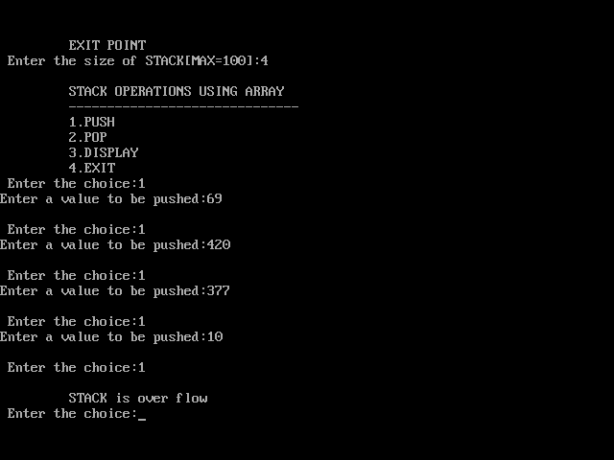

**Conclusion:**

Hence we've successfully run the stack ADT using array program.

v